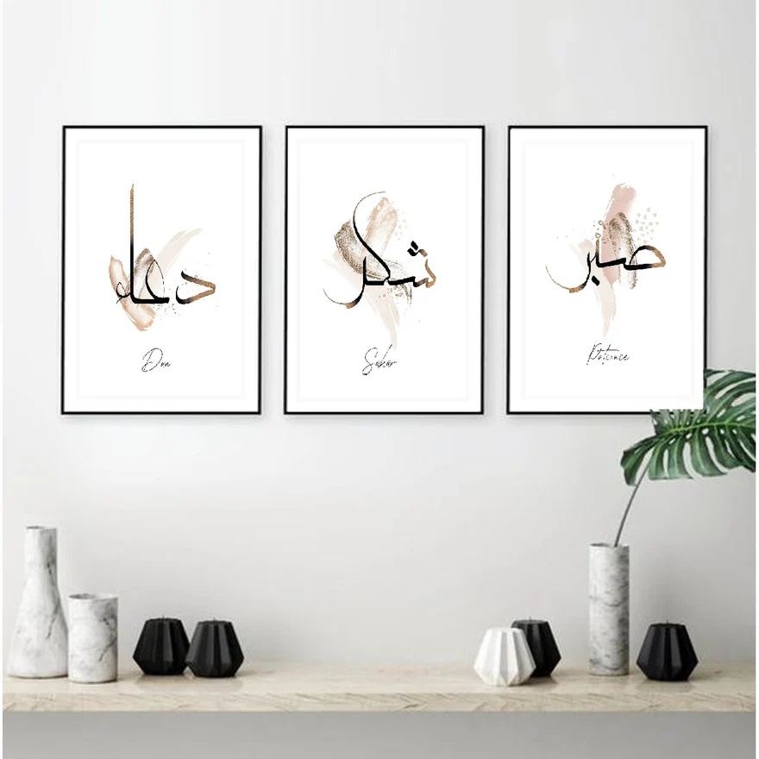**Sabar Shukar Dua 3 Pc Islamic Calligraphy Frame set**

This image showcases a chic and minimalist interior design featuring a set of three framed artworks with Arabic calligraphy. Each piece displays a meaningful word—"Dua" (prayer), "Shukr" (gratitude), and "Sabr" (patience)—accompanied by soft, abstract brushstrokes in neutral beige and metallic hues. Below the artwork, a wooden console is styled with marble and geometric vases in white and black, adding a contemporary touch. A lush green plant on the side introduces a refreshing natural element, perfectly balancing the sophisticated and serene atmosphere of the space.